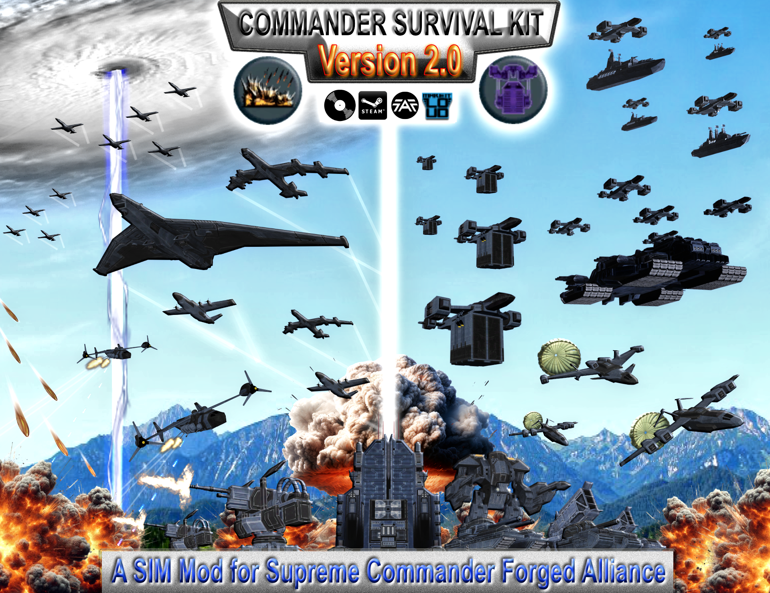

Description:
The Commander Survival Kit (short C.S.K.) is an Sim Mod for the Game Supreme Commander Forged Alliance.
It adds these following Features:

Reinforcement Manager:

With this Manager you are able to call in Land, Air, Naval or Space Reinforcements on the Map.
Note: Space Reinforcements requires the activation of FBP Orbital for access

--------------------------------------------------------------------------------

Fire Support Manager

With this Manager your are able to call in Fire Support on the Map.
For example Air Strikes, Drop Defenses, Artillery Barrages, Missile Salvos or Beams
--------------------------------------------------------------------------------

Helpcenter (Tutorials):

Here you can find some Video Tutorials about the following topics:
How to call Land Reinforcements?
How to call Artillery Barrages?
And several more

Note:
The Helpcenter is under maintaince in this Release and will be available again in an following Update.

What is new since Version 1.71?

As an Major Release Version 2.0 includes several new Features and Functions.
Some of them can change the Gameplay Experience with the Mod.
Others will Lock/Unlock new callable Stuff for the Player in an Match and can be set with an Lobby Option.
The List below gives you an General Overview about the new Features in Version 2.0:

- Naval Reinforcements Manager
- Callable Experimental Reinforcements (Optional)
- Callable Experimental Air Strikes (Optional)
- Campaign Options Manager (For Retail/Steam Only)
- Callable Drop Defenses
- Point Generation Centers
- Point Storages
- HQ Communication Center
- 5 new callable Air Strikes for each Faction (2 more for UEF)
- 12 new Lobby Options
- Squadron Size Sliders for all callable Air Strikes
- New Main Air Strike Mechanic: Attack Marker Location
- Several UI Improvements:
Introduce the new Support Panel
Techlevel Sections for all Reinforcement Managers
- Callable Strategic Missiles and Anti Strategic Missiles
- Several Spawm Improvements for Air Strikes (Expandable Maps are now Supported)
- The Origin of Air Strikes and all UEF Reinforcements and UEF Drop Defenses can now be set with new Origin Combo Box
Options are: North, South, East, West and Random
- Reworked Drop Mechanic for all UEF Land Reinforcements

Naval Reinforcements Manager

Naval Units are now callable as Reinforcements
For example: Submarines, Destroyers, Cruisers, Frigates, Battleships or even Aircraft Carries.
You can now Manage the Access to each Reinforcement Manager with these fllowing Lobby Options:
„Land Reinforcements“, „Air Reinfocements“ and „Naval Reinforcements“

Callable Experimental Reinforcements (Optional)

Experimental Units are now callable as Reinforcements
For example: the Monkeylord, Megalith, Fatboy, Ahwassa, Soul Ripper, Atlantis and more
However there are usually not callable by Default.
So you will need to set the following Lobby Option „Experimental Reinforcements“ to „Callable“

Callable Experimental Air Strikes (Optional)

Each Faction has get access to an Experimental Bomber Air Strike
However there are usually not callable by Default.
So you will need to set the following Lobby Option „Experimental Air Strikes“ to „Callable“

Campaign Options Manager (For Retail/Steam Only)

If you play the Campaign in the Steam or Retail Version of the Game.
You can now set all Lobby Options with this Manager at the beginning of each Mission.
The Game will be automatically Paused so you have enough time to set your Options.
The First Campaign Mission „Black Day“ has been modified.
So the Faction Selection Window has been replaced with the Access of the Faction Selection Option in the Mission Briefing.
Note: The Installation of the included CSKMainMenu.scd is required to make it functional

Callable Drop Defenses

Each Faction is now able to call in 2 different Drop Turrets and a Drop Supply Station on the Battlefield.
All three have access to Enhancement Upgrades which gives them new Weapons, Abilities or other Improvements.
There are now callable from the Section Drop Defenses of the Fire Support Manager.
Of course you can Manage the Access to them with these fllowing Lobby Option:
„Drop Turrets and Devices“

Structure related Gameplay now available:
Version 2.0 includes 3 new Lobby Options which gives your Access to 5 special Structures.
Each of them has an purpose, which makes the Gameplay much more Structure Related.
Or they give you an additional Boost if needed.

Point Generation Centers

Each Faction can build two new Tech 2 Structures which generates Points for both Managers.
Reinforcement Center = Point Generation for the Reinforcement Manager
Tactical Center = Point Generation for the Fire Support Manager
Each Player can only build 5 of both Centers in Total and each of them will Increase the Point Generation Rate with 1 Point.
You will notice that they will disappear from the Buildlist if you have build 5.
But don’t worry once you have lose one or multiple of them they will be buildable agian and reappear in the Buildlist
However these two Structures are usually not buildable by Default.
So you will need to set the following Lobby Option „Point Generation Centers“ to „Buildable“
.
Point Storages

Each Faction can build two new Tech 2 Structures which is able increase the collectable Points for both Managers.
Reinforcement Point Storage = Increase the Maximum of collectable Reinfocement Points for the Reinforcement Manager
Tactical Point Storage = Increase the Maximum of collectable Tactical Points for the Fire Support Manager
Each Player can only build 1 of both Storages in Total and each of them will Increase the collectable Point Storage with 1000 Points.
You will notice that they will disappear from the Buildlist if you have build 1
But don’t worry once you have lose them of them they will be buildable agian and reappear in the Buildlist
Both Structures can be Upgraded from Level 1 to Level 5 which Increase the collectable Point Storage with 1000
However these two Structures are usually not buildable by Default.
So you will need to set the following Lobby Option „Point Storages“ to „Buildable“

HQ Communication Center

If you set the Lobby Option „HQ Communication Center“ to „Buildable“
You will notice that the two Main Buttons for both Managers are disabled/locked in the Support Panel.
Each Player is able to build only one HQ Communication Center in an Match, which is an Tech 2 Building for each Faction.
Once you have build it it will unlock/enable both Main Buttons, which gives you the Access to both Managers.
However keep in Mind if you lose this Structure you will lose the access to both Managers again.
So make sure to Defend it at all cost or rebuild it if you have lose it.

New Additions to Air Strikes and Improvements:
The Spawn Mechanic of Air Strikes has been Improved to support Expandable Maps much more.
For example Maps with one or multiple Playable Areas such as Campaign or special Skirmish Maps are now supported.
The Mod itself comes now with an integrated System to setup an Playable Area on each Map if they doesn’t has one or is simple not correctly etablished.

The new Air Strike Mechanic: Attack Marker Location is the regular now.
Air Strikes will now directly attack the Location which you have set on the Map and fly back to the Map Border and disappear after that.
However if you want to play with the old Full Route Mechanic you can Manage both Mechanics with the new Lobby Option:
„Air Strike Mechanic“

Of course you can now directly Manage the Access to callabe Air Strikes with the new Lobby Option:
„Air Strikes“

The Size of the Squadrons of several callable Air Strikes can now be set with an specific Slider.
Previously in Version 1.71 several Air Strikes had specifc callable Squadron Sizes.
However with Version 2.0 the Value Range of Squadron Sizes has been expanded and support now much more Values.
Keep in Mind if you increase the Size of the Squadrons with the Slider the Price for Tactical Points will increase as well.

Each Faction has get access to these 5 new regular Air Strikes:
- Torpedo Bomber Air Strike
- Heavy Bomber Air Strike
- 2 different Ground Attack Fighter Air Strikes
- Patrol Gunship Air Strike

The UEF has get two new addional Adanced Strategic Bomber Air Strikes as an replacement of two old callable Special Barrages
But has get a few new Additions to the Special Section instead.
For example an Callabe Smoke Screen Barage an EMP Barage and a few more.

Note:
Unlike the other callabe Air Strikes the new Patrol Gunship Air Strike is diffferent in its functionality.
As an Support Air Strike Players are able to select the Patrol Gunship and are able to give them Orders as they want.
Once they have fire for the First Time they will run out of Ammo after a while and fly back to the Map Border and disappear
However I recommend to setup an Patrol Route around the Target to make them more effective.
The UEF Patrol Gunship requires an Patrol Route in this case because the Weapons are only mounted on a Single Side of its Hull.

